The Alde River Benefice

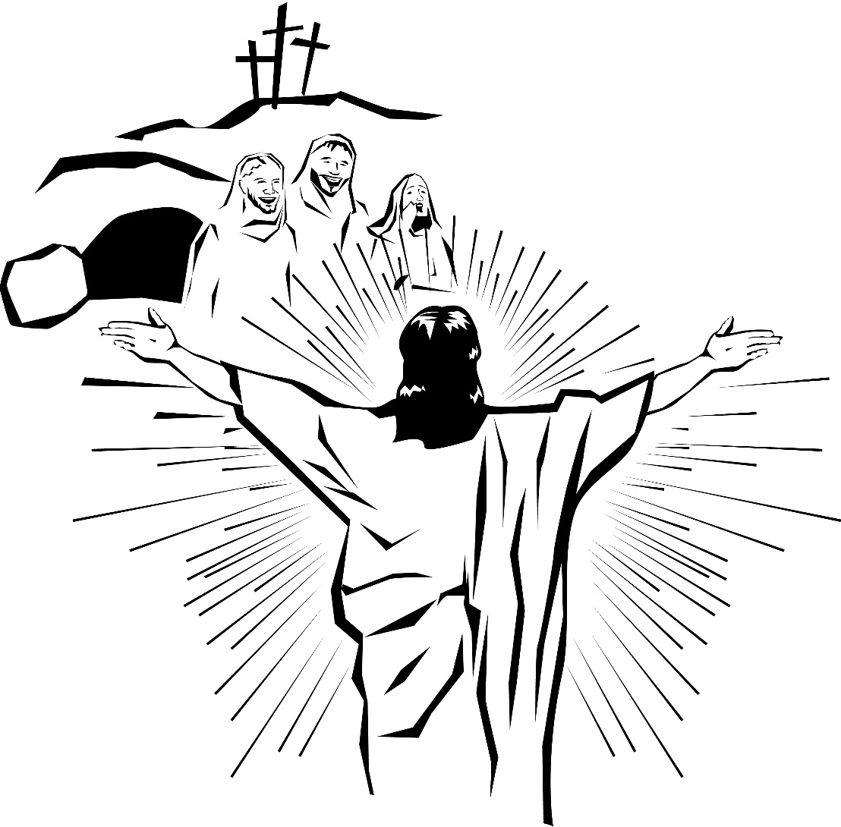

Holy Communion
On Easter Day

¶ The Gathering

The ministers gather at the west end of the church.

The president says

Christ yesterday and today,
All the beginning and the end,

Alpha and Omega,
all the time belongs to him,
and all ages;
All to him be glory and power,
through every age and for ever. Amen.

The president proclaims

Alleluia! Christ is risen
All He is risen indeed. Alleluia, alleluia, alleluia

The president says

This is the day when our Lord Jesus Christ was raised gloriously from the dead crushing the sin’s power and destroying death’s sting. Throughout the world Christians celebrate the awesome power of God as Christ calls us out of darkness to share in his marvellous light. May we, and all Christ’s people, shine as lights in the world to the glory of God the Father.

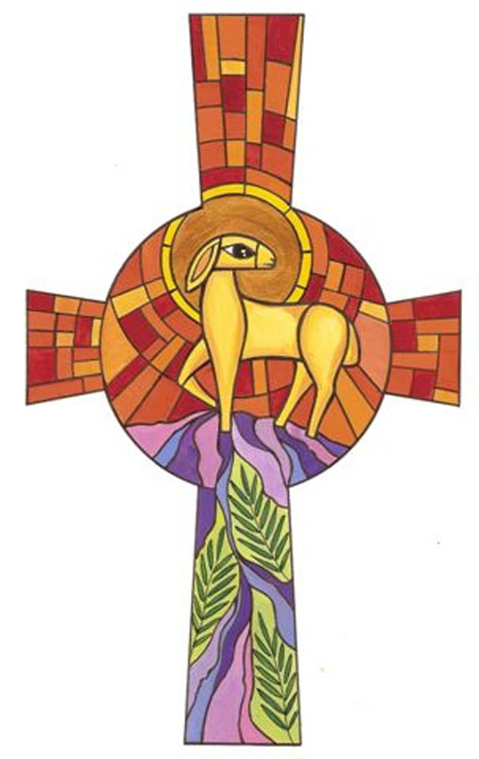
The president holding the candle says,

Christ our Light.
All Thanks be to God.

Hymn

Acclamation

Alleluia. Christ is risen.
All He is risen indeed. Alleluia.

Praise the God and Father of our Lord Jesus Christ.
All He has given us new life and hope
by raising Jesus from the dead.

God has claimed us as his own.
All He has made us light to the world.

Alleluia. Christ is risen.
All He is risen indeed. Alleluia.

Gloria in Excelsis

All Glory to God in the highest,
and peace to his people on earth.

Lord God, heavenly King,
almighty God and Father,
we worship you, we give you thanks,
we praise you for your glory.

Lord Jesus Christ, only Son of the Father,
Lord God, Lamb of God,
you take away the sin of the world:
have mercy on us;
you are seated at the right hand of the Father:
receive our prayer.

For you alone are the Holy One,
you alone are the Lord,
you alone are the Most High, Jesus Christ,
with the Holy Spirit,
in the glory of God the Father.
Amen.
Prayers of Penitence
In baptism we died with Christ, so that as Christ was raised from the dead, we might walk in newness of life. Let us receive new life in him as we confess our sin in penitence and faith.

Silence

Lord Jesus, you raise us to new life.
Lord have mercy
All Lord have mercy.

Lord Jesus, you forgive us our sins.
Christ have mercy.
All Christ have mercy.

Lord Jesus, you feed us with the living bread.
Lord have mercy.
All Lord have mercy.

Absolution
Almighty God, who forgives all who truly repent,
have mercy upon you,
pardon and deliver you from all your sins,
confirm and strengthen you in all goodness,
and keep you in life eternal;
through Jesus Christ our Lord.
All Amen.

The Collect
Let us pray that we may bear witness to the Risen Lord.

Lord of all life and power,
who through the mighty resurrection of your Son
overcame the old order of sin and death
to make all things new in him:
grant that we, being dead to sin and alive to you in Jesus Christ,
may reign with him in glory;
to whom with you and the Holy Spirit
be praise and honour, glory and might, now and in all eternity.
All Amen.
¶ The Liturgy of the Word
Reading
at the end the reader says

This is the word of the Lord
All Thanks be to God

Hymn

Gospel Reading

Hear the Gospel of our Lord Jesus Christ according to ………………
All Glory to you, O Lord.

at the end the reader says

This is the Gospel of the Lord.
All Praise to you, O Christ.

Sermon

Profession of Faith
Brothers and Sisters I ask you to profess the faith of the Church.

Do you believe and trust in God the Father?
All I believe in God, the Father Almighty, creator of heaven and earth,
Do you believe and trust in his Son Jesus Christ?
All I believe in Jesus Christ, his only Son, our Lord,
who was conceived by the Holy Spirit,
born of the Virgin Mary,
suffered under Pontius Pilate,
was crucified, died, and was buried;
he descended to the dead.
On the third day he rose again;
he ascended into heaven,
he is seated at the right hand of the Father,
and he will come to judge the living and the dead.

Do you believe and trust in the Holy Spirit?
All I believe in the Holy Spirit,
the holy catholic Church,
the communion of saints,
the forgiveness of sins,
the resurrection of the body,
and the life everlasting.
Amen.

Prayers of Intercession
The prayers include the response:

Jesus, Lord of life
All in your mercy, hear us.

The prayers end with

All accept our prayers
and be with us always.
Amen.

¶ The Liturgy of the Sacrament
The Peace

The risen Christ came and stood among his disciples
and said, ‘Peace be with you.’
Then were they glad when they saw the Lord. Alleluia.
The peace of the Lord be always with you
All and also with you.

Let us offer one another a sign of peace.

All may exchange a sign of peace, greeting one another with these words

Christ is risen.

Preparation of the Table
Taking of the Bread and Wine

Hymn

The table is prepared and bread and wine are placed upon it.
Lord, of life,
with unbounded joy we offer you our sacrifice of praise.
As we are fed with the bread of heaven
may we know your resurrection power;
through Christ our risen Lord.
All Amen

The Eucharistic Prayer

The Lord be with you
All and also with you.

Lift up your hearts.
All We lift them to the Lord.

Let us give thanks to the Lord our God.
All It is right to give thanks and praise.

It is indeed right, our duty and our joy,
always and everywhere to give you thanks,
almighty and eternal Father,
and in these days of Easter
to celebrate with joyful hearts
the memory of your wonderful works.
For by the mystery of his passion
Jesus Christ, your risen Son,
has conquered the powers of death and hell
and restored in men and women the image of your glory.
He has placed them once more in paradise
and opened to them the gate of life eternal.
And so, in the joy of this Passover,
earth and heaven resound with gladness,
while angels and archangels and the powers of all creation
sing for ever the hymn of your glory:
All Holy, holy, holy Lord,
God of power and might,
heaven and earth are full of your glory.
Hosanna in the highest.
Blessed is he who comes in the name of the Lord.
Hosanna in the highest.
We praise and bless you, loving Father,
through Jesus Christ, our Lord;
and as we obey his command, send your Holy Spirit,
that broken bread and wine outpoured
may be for us the body and blood of your dear Son.
On the night before he died he had supper with his friends
and, taking bread, he praised you.
He broke the bread, gave it to them and said:
Take, eat; this is my body which is given for you;
do this in remembrance of me.
When supper was ended he took the cup of wine.
Again he praised you, gave it to them and said:
Drink this, all of you;
this is my blood of the new covenant,
which is shed for you and for many for the forgiveness of sins.
Do this, as often as you drink it, in remembrance of me.
So, Father, we remember all that Jesus did,
in him we plead with confidence his sacrifice
made once for all upon the cross.
Bringing before you the bread of life and cup of salvation,
we proclaim his death and resurrection
until he comes in glory.

Jesus Christ is Lord:
All Lord, by your cross and resurrection
you have set us free.
You are the Saviour of the world.

Lord of all life, help us to work together for that day
when your kingdom comes
and justice and mercy will be seen in all the earth.
Look with favour on your people,
gather us in your loving arms
and bring us with all the saints
to feast at your table in heaven.

Through Christ, and with Christ, and in Christ,
in the unity of the Holy Spirit,
all honour and glory are yours, O loving Father,
for ever and ever.
All Amen.

The Lord’s Prayer

Rejoicing in God’s new creation,
as our Saviour taught us, so we pray
All Our Father, who art in heaven,
hallowed be thy name;
thy kingdom come;
thy will be done;
on earth as it is in heaven.
Give us this day our daily bread.
And forgive us our trespasses,
as we forgive those who trespass against us.
And lead us not into temptation;
but deliver us from evil.
For thine is the kingdom,
the power and the glory,
for ever and ever.
Amen.

Breaking of the Bread

The president breaks the consecrated bread.

Every time we eat this bread and drink this cup,
All we proclaim the Lord’s death until he comes.

Agnus Dei

All Lamb of God, you take away the sin of the world,
have mercy on us.

Lamb of God, you take away the sin of the world,
have mercy on us.

Lamb of God, you take away the sin of the world,
grant us peace.

Giving of Communion

The president says the invitation to communion

Alleluia. Christ our Passover is sacrificed for us.
All Therefore let us keep the feast. Alleluia.

The president and people receive communion.

The body of Christ and The blood of Christ.

If you are visiting us this morning and it is your normal practice to receive the
bread and wine of communion, in whichever is your normal tradition, then we invite you to come forward and receive the sacrament today. If it is not, or you would prefer to
receive a blessing then we also welcome you to come forward,
but ask you to please bring this service sheet with you.

During the distribution hymns and anthems may be sung.

Prayer after Communion

Silence is kept.

God of Life,
who for our redemption gave your only-begotten Son
to the death of the cross,
and by his glorious resurrection
have delivered us from the power of our enemy:
grant us so to die daily to sin,
that we may evermore live with him in the joy of his risen life;
through Jesus Christ our Lord.
All Amen.
All Father of all, we give you thanks and praise,
that when we were still far off
you met us in your Son and brought us home.
Dying and living, he declared your love,
gave us grace, and opened the gate of glory.
May we who share Christ’s body live his risen life;
we who drink his cup bring life to others;
we whom the Spirit lights give light to the world.
Keep us firm in the hope you have set before us,
so we and all your children shall be free,
and the whole earth live to praise your name;
through Christ our Lord.
Amen.
¶ The Dismissal
Hymn

Blessing

God the Father,
by whose love Christ was raised from the dead
open to you who believe the gate of everlasting life.
All Amen.

God the Son,
who in bursting from the grave
has won a glorious victory,
give you joy as you share the Easter faith.
All Amen.

God the Holy Spirit,
who filled the disciples with the life of the risen Lord,
empower you and fill you with Christ’s peace.
All Amen.

And the blessing of God Almighty,
the Father, the Son and the Holy Spirit
rest upon you, your homes and
all who you love, this Easter day and always.
All Amen
a minister says

Jesus is alive!
We have heard the good news
All Let’s share it with the world

Jesus is alive!
We have heard the good news
All Let’s live it in our lives. Alleluia!

He is not here, He is risen.
Go in the peace of Christ. Alleluia, Alleluia.
All Thanks be to God. Alleluia, Alleluia.

We wish you a happy Easter and pray that we may each know the power and joy of the risen Christ.

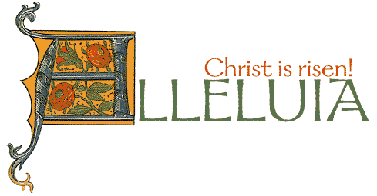

Common Worship: Services and Prayers for the Church of England, material from which is included in this service, is copyright © The Archbishops’ Council 2000.
Common Worship: Times and Seasons, material from which is included in this service, is Copyright © The Archbishops’ Council 2006.

